**NAAN MUDHALVAN REPORT**

**COLLEGE CODE** 3116

**COLLEGE NAME** MisrimalNavajee Munoth Jain

                                         Engineering College

**DEPARTMENT** Computer Science and Business Systems

**STUDENT NM – ID**  620a68f5fe20fba96d94bb57ebbc74ce

**REGISTER NUMBER** 311623244013

**DATE** 08/05/2025

**TECHNOLOGY**AI-Driven Natural Disaster Prediction

& Management System

**SUBMITTED BY,**

Lourdhu Priscilla A

lourdhupriscilla@gmail.com

**Phase 5: Project Demonstration & Documentation**

**Title: AI-Driven Natural Disaster Prediction & Management System**

# Abstract:

# 

This project presents an innovative cyclone and storm alert system that predicts storm paths, provides visual notifications tailored to different literacy levels, and features a community forum for discussion and support. By leveraging advanced predictive modeling and user-centric design, the system enhances disaster preparedness and community resilience, ultimately saving lives and reducing the impact of cyclones and storms.

**2**

|  |  |  |
| --- | --- | --- |
| **SECTION** | **TITLE** | **PAGE NO** |
| 01 | Project Demonstration Overview | 4 |
| 02 | Project Documentation Overview | 5 |
| 03 | Feedback and Final Adjustments Overview | 6 |
| 04 | Final Project Report Submission Overview | 6 |
| 05 | Project Handover and Future Works Overview | 7 |
| 06 | Source Code | 8 |
| 07 | Output | 11 |

**3**

1.**Project Demonstration Overview:**

**Overview:**

In Phase 5, The *AI-Powered Natural Disaster Management System* will be demonstrated to highlight its real-time cyclone/storm prediction, visual alert system for all literacy levels, and community support forum. The system is designed for inclusivity, accuracy, and reliability in disaster-prone scenarios

### ****Demonstration Details:****

* **System Walkthrough:**

A live walkthrough will show how the platform predicts disasters, notifies users through visual alerts and allows interaction via a community forum interface.

* **Disaster Prediction Accuracy:**

Demonstration of AI models forecasting cyclone and storm paths using meteorological data.

* **Visual Notifications**:

Showcase of inclusive visual alerts that are understandable across all literacy levels and languages.

* **Community Forum**:

A demonstration of how users can seek help, share local updates, and interact in emergency situations via a moderated forum.

* **Performance Metrics**:

The system’s ability to handle data, multiple users, and scalable alert delivery will be shown.

* **Security & Privacy**:

A brief explanation of how user location and identity data are securely managed during alert handling.

* **Outcome**:

The demo confirms the system's capability to provide accurate disaster warnings, inclusive alerts, and strong community support—ensuring readiness for real-world lol.

**4**

2.**Project Documentation Overview:**

**Overview**:

Comprehensive documentation is prepared to detail every component of the disaster management system, ensuring it can be maintained, scaled, and understood by future developers and users.

**Documentation Sections**:

* **System Architecture**:

Diagrams showing AI prediction flow, visual alert logic, and user/forum interactions.

* **Code Documentation**:

Well-commented source code for cyclone/storm path prediction, alert delivery modules, and forum functionalities.

* **User Guide**:

Simple instructions for users on how to receive alerts and participate in the community forum.

* **Administrator Guide**:

Maintenance procedures, system updates, and community moderation tools.

* **Testing Reports**:

Performance results for alert speed, prediction accuracy, and platform scalability.

* **Outcome**:

All system features are clearly documented, enabling seamless handover, future development, and practical deployment

**5**

3.**Feedback and Final Adjustments Overview:**

**Overview:**

Feedback will be collected from instructors and test users to refine the disaster management system before final handover.

**Steps**:

* **Feedback Collection**:

Through surveys and demo observations, feedback on prediction accuracy, alert delivery, and forum usability will be gathered.

* **Refinement**:

System adjustments will focus on improving forecast accuracy, alert visibility, and user interaction.

* **Final Testing**:

Re-testing will validate system performance, accessibility, and community support functions.

* **Outcome**:

Final adjustments will improve system reliability, inclusivity, and readiness for real-world emergency response.

4.**Final Project Report Submission Overview:**

**Overview**:

The final report summarizes the complete development of the disaster prediction and management platform, including milestones, challenges, and system performance.

**Steps**:

* **Executive Summary:**

A high-level overview of the system's purpose, functionality, and achievements.

* **Phase Breakdown**:

Key phases such as AI model training, data integration, visual alert design, and forum creation are outlined.

**6**

* **Challenges & Solutions**:

Includes issues like forecast delays, low-literacy accessibility, and user moderation—with applied solutions.

* **Testing & Results**:

Summary of system performance under load, alert timing, and user experience feedback.

* **Outcome**:

The report reflects the system’s evolution from concept to deployment-ready solution, supporting further improvements and scale-up.

**5.Project Handover and Future Works Overview:**

**Overview**:

The project handover marks the transition of the disaster management system to the next phase of implementation and expansion.

**Handover**:

* Complete code, documentation, and user manuals will be handed over.

* Suggestions for future work include:

• Scaling for national/regional use

• Expanding multilingual and offline alert capabilities

• Enhancing community features and moderator tools

• Integrating satellite and sensor data for improved accuracy

**Outcome**:

The system will be officially handed over with guidance for future upgrades, ensuring it remains a vital tool for protecting communities from natural disasters.

**7**

**Source Code:**

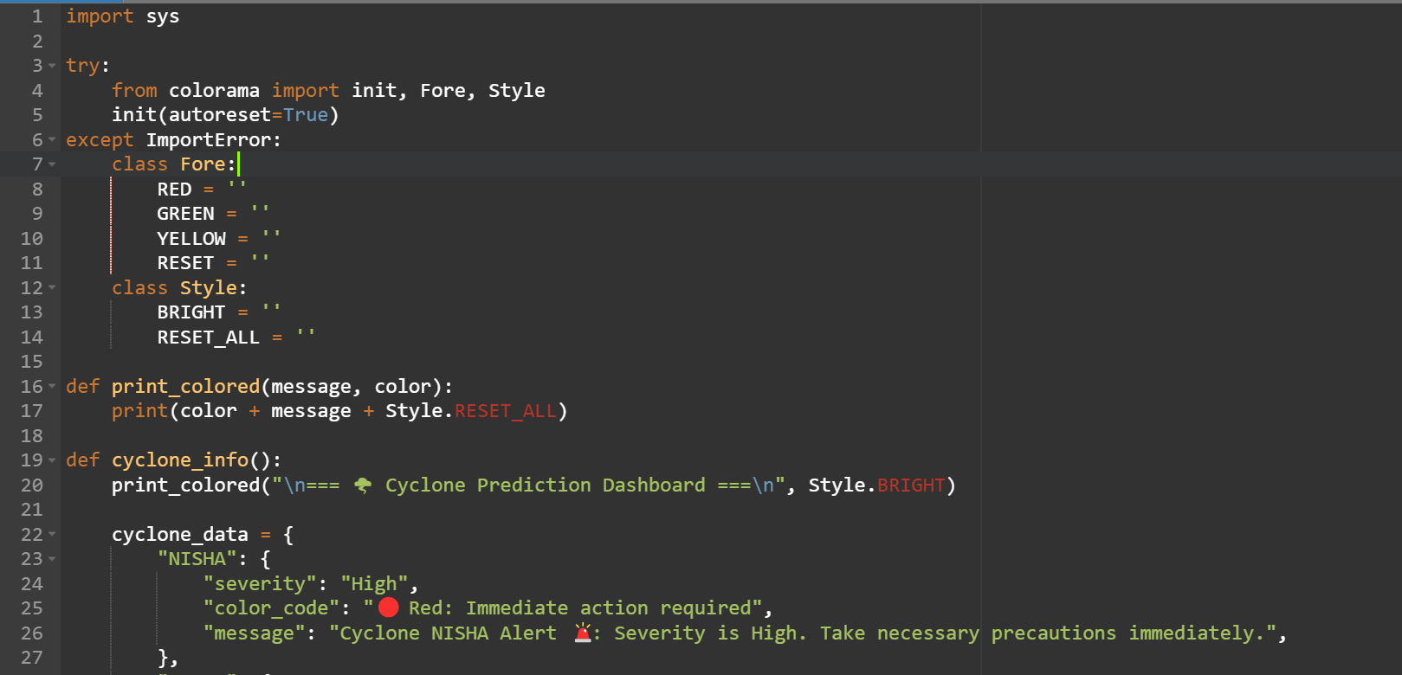

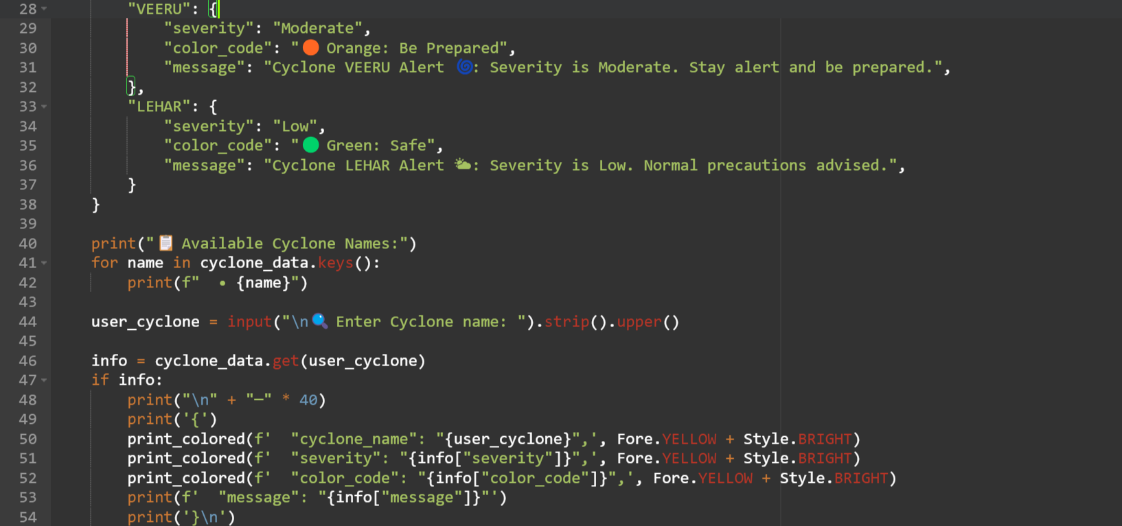

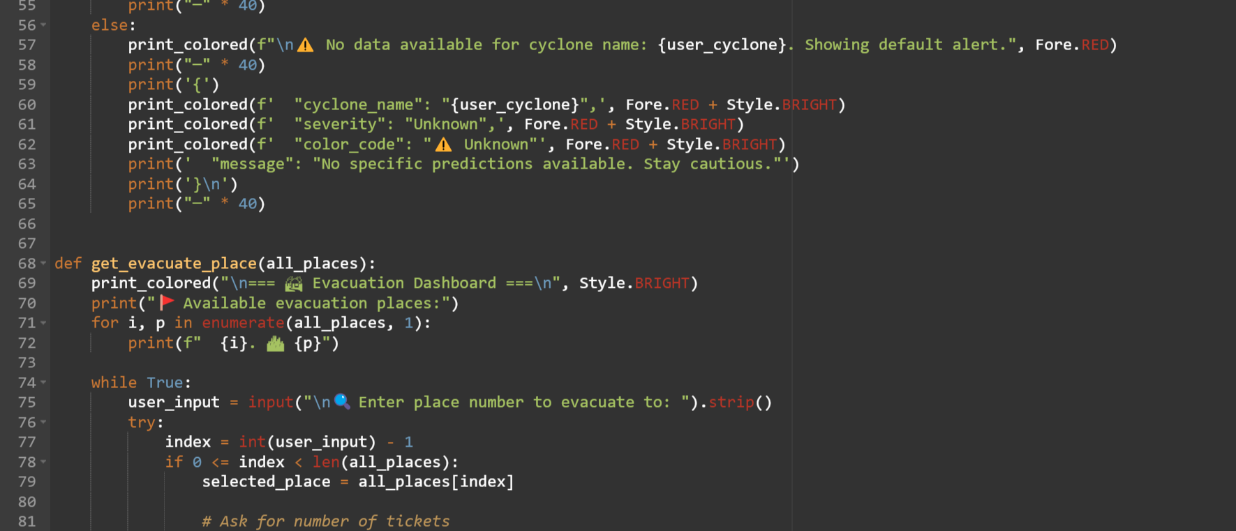

**8**

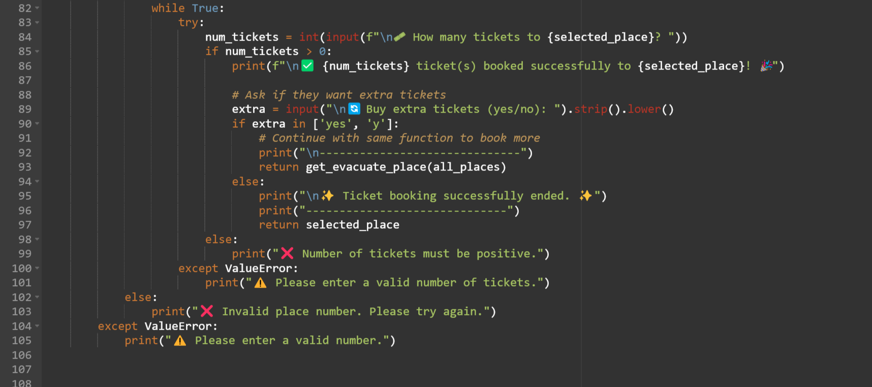

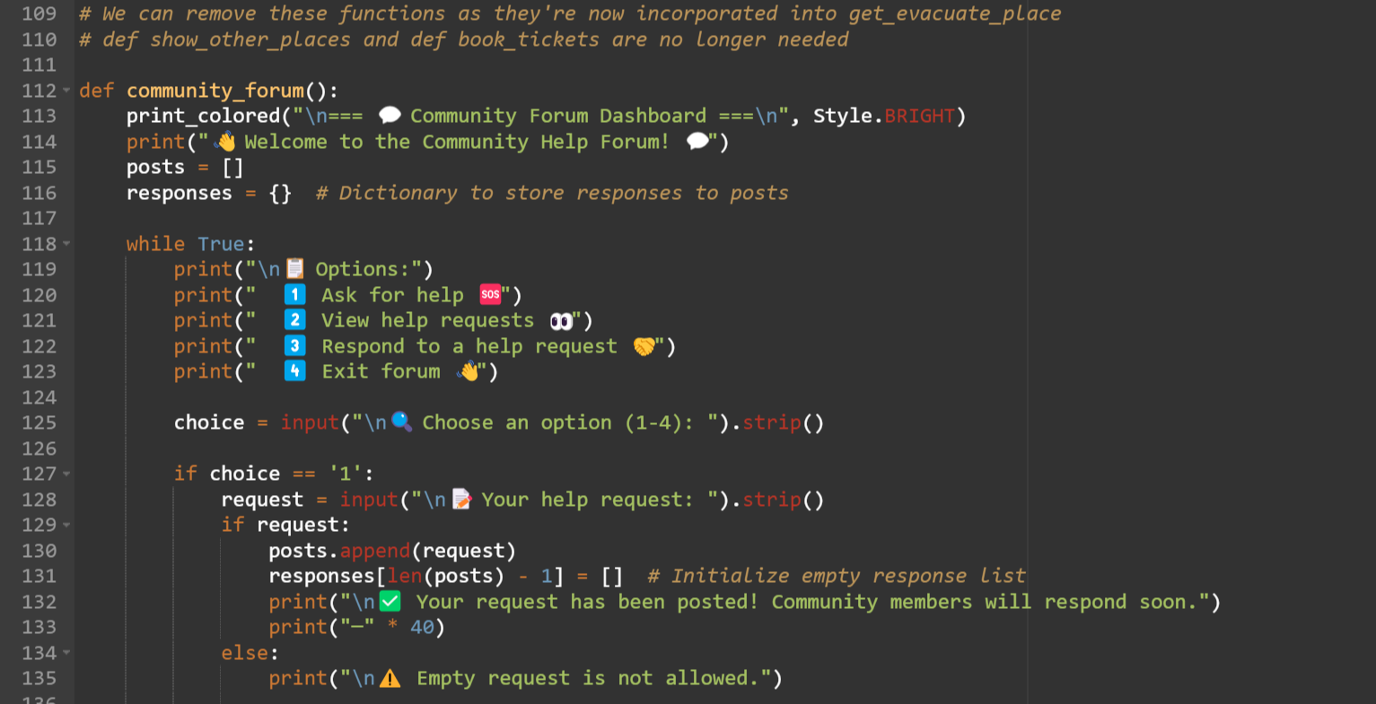

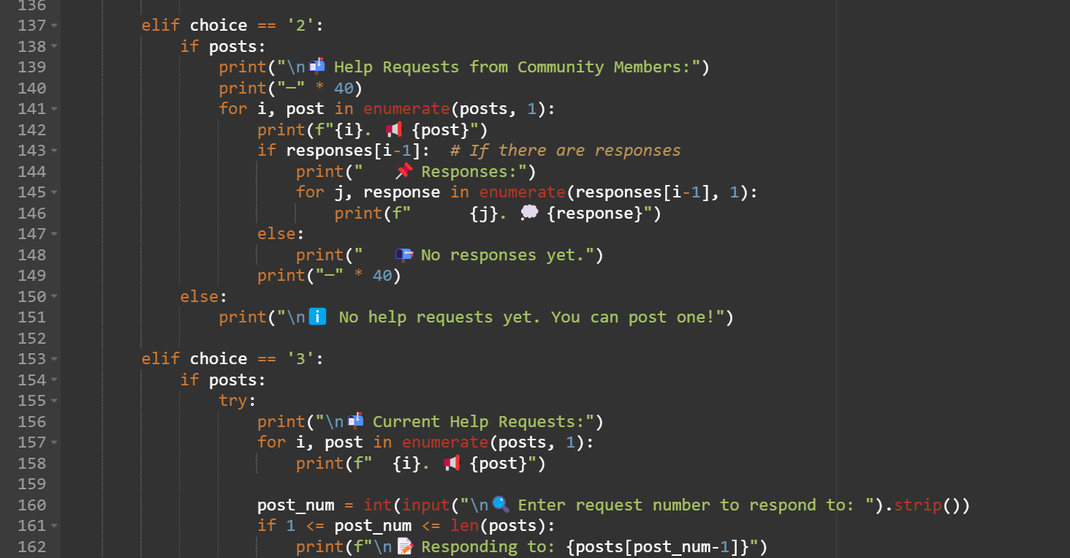

**9**

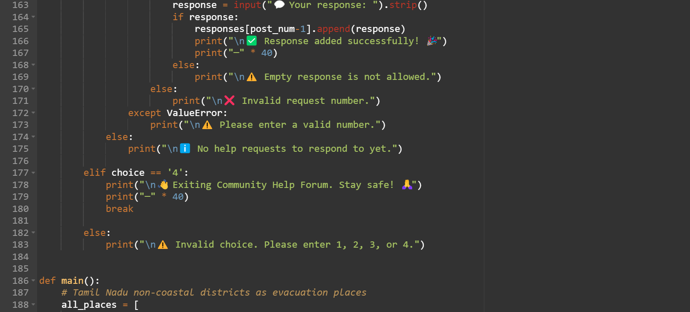

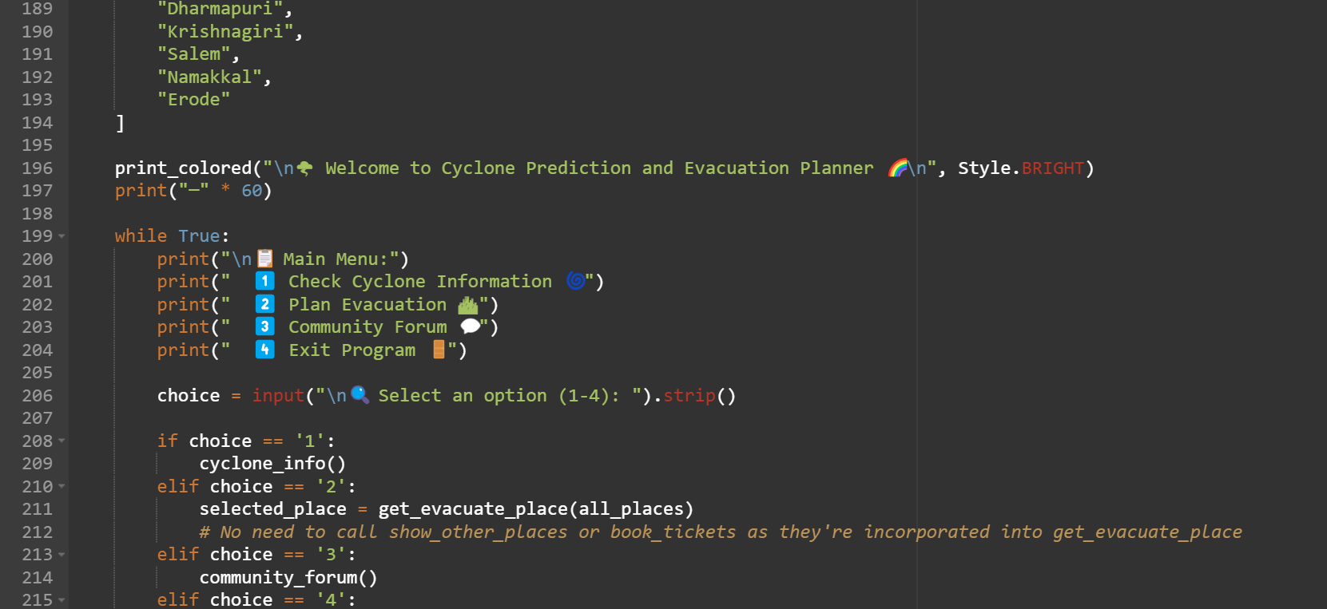

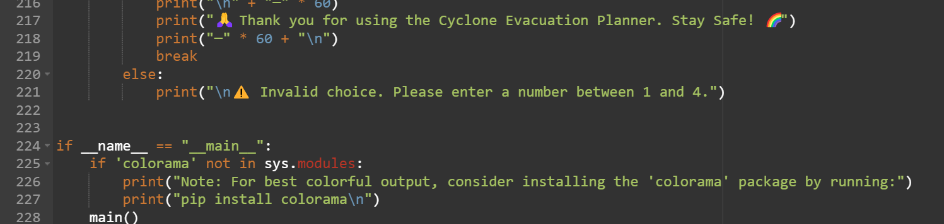

**10**

**OUTPUT:**

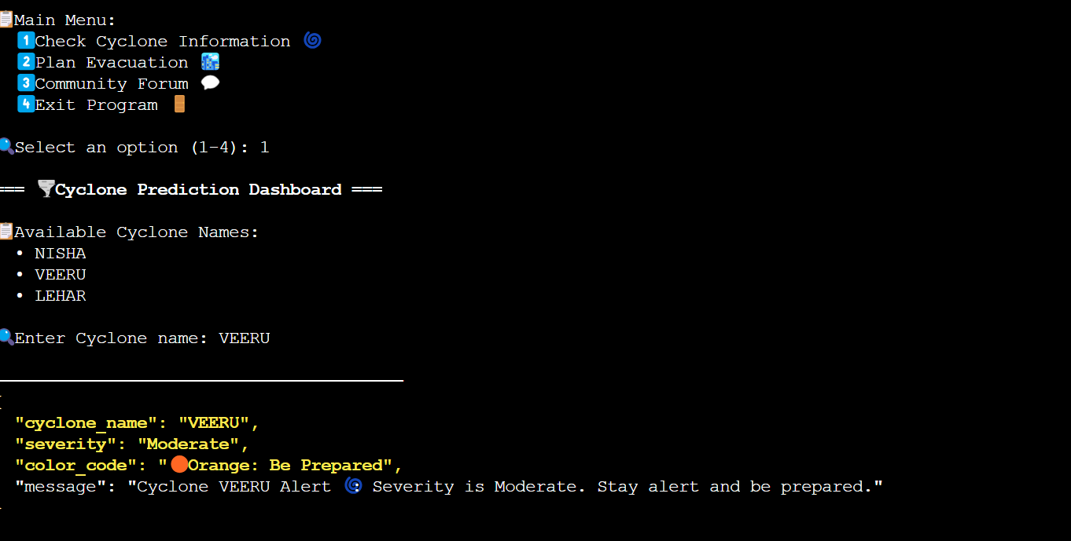

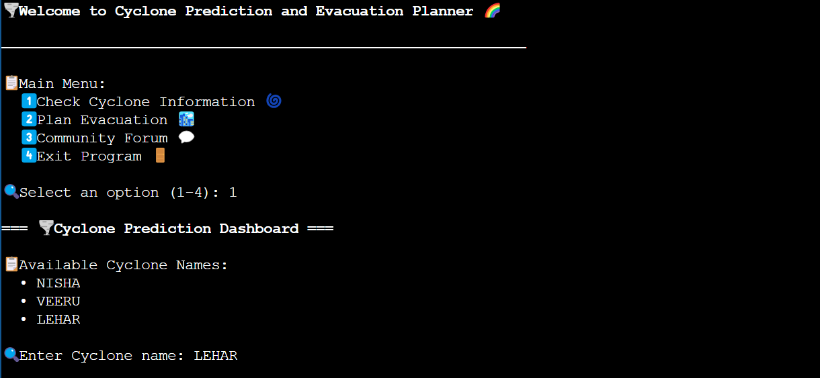

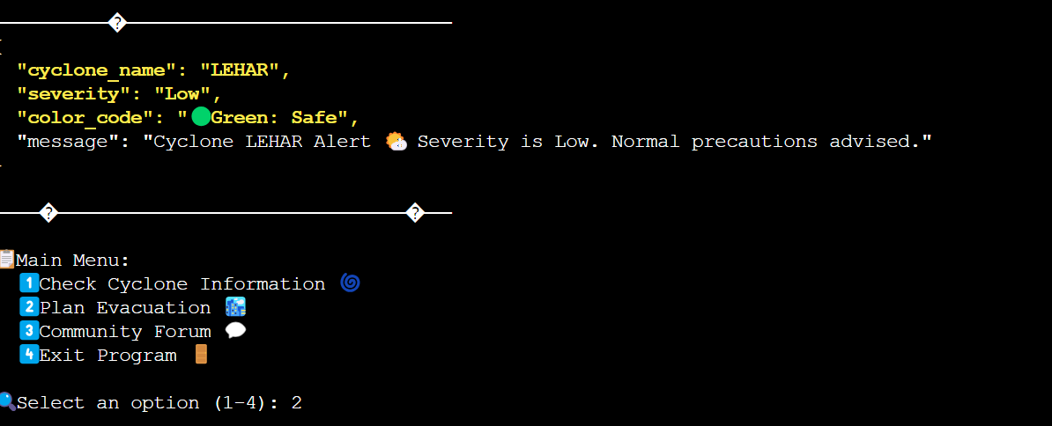

**11**

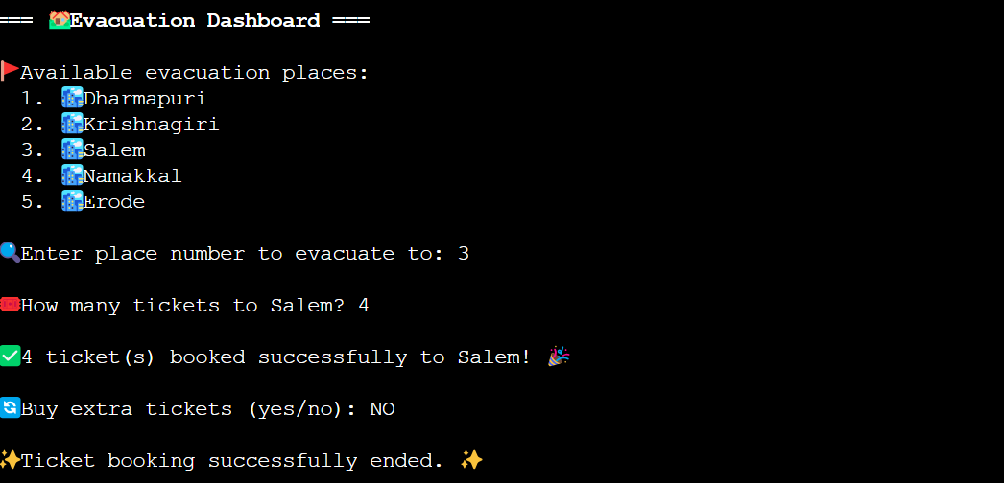

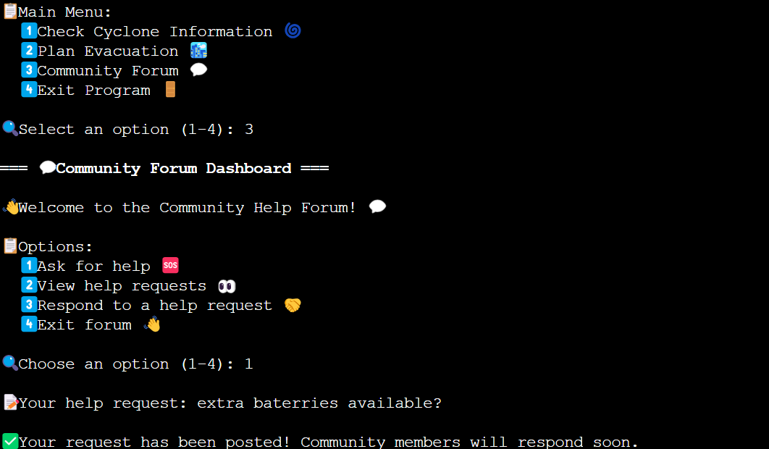

**12**

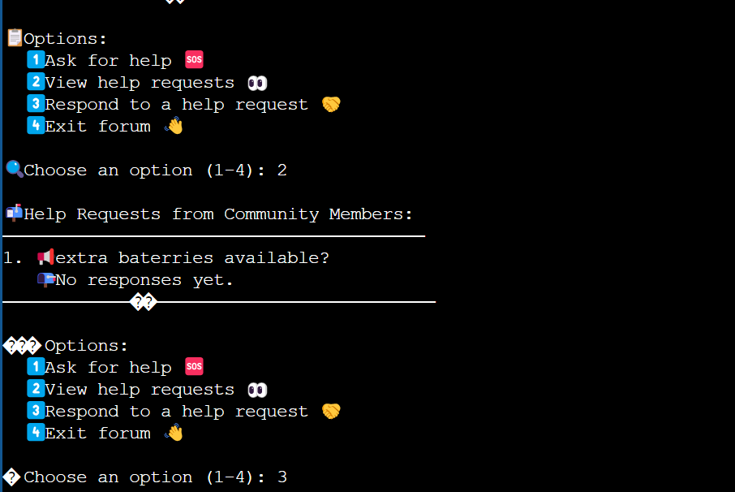

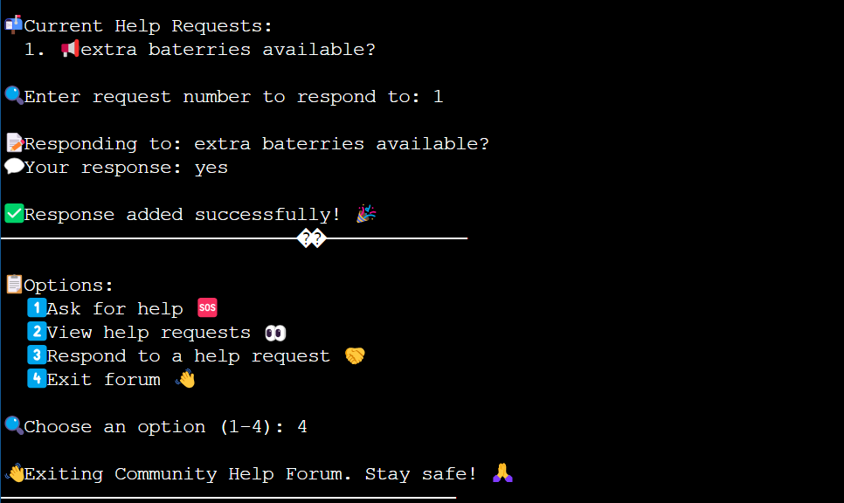

**TEAM MEMBERS:**

* Kanagavel (311623244011)
* Karthikeyan B (311623244012)
* Nivethitha P (311623244016)
* Thivahar J (311623244022)

**13**